Project Design Phase
Solution Architecture
Date | 1 October 2026
Team ID | SWTID-2026-3491
Project Name | Import Data using Transform Maps (Spreadsheet)
Maximum Marks | 4 Marks

Solution Architecture:
Solution architecture is a complex process with many sub-processes that bridges the gap between business problems and technology solutions. Its goals are to:
- Find the best tech solution to solve existing business problems.
- Describe the structure, characteristics, behaviour and other aspects of the software to project stakeholders.
- Define features, development phases and solution requirements.
- Provide specifications according to which the solution is defined, managed and delivered.

Solution Architecture Diagram:
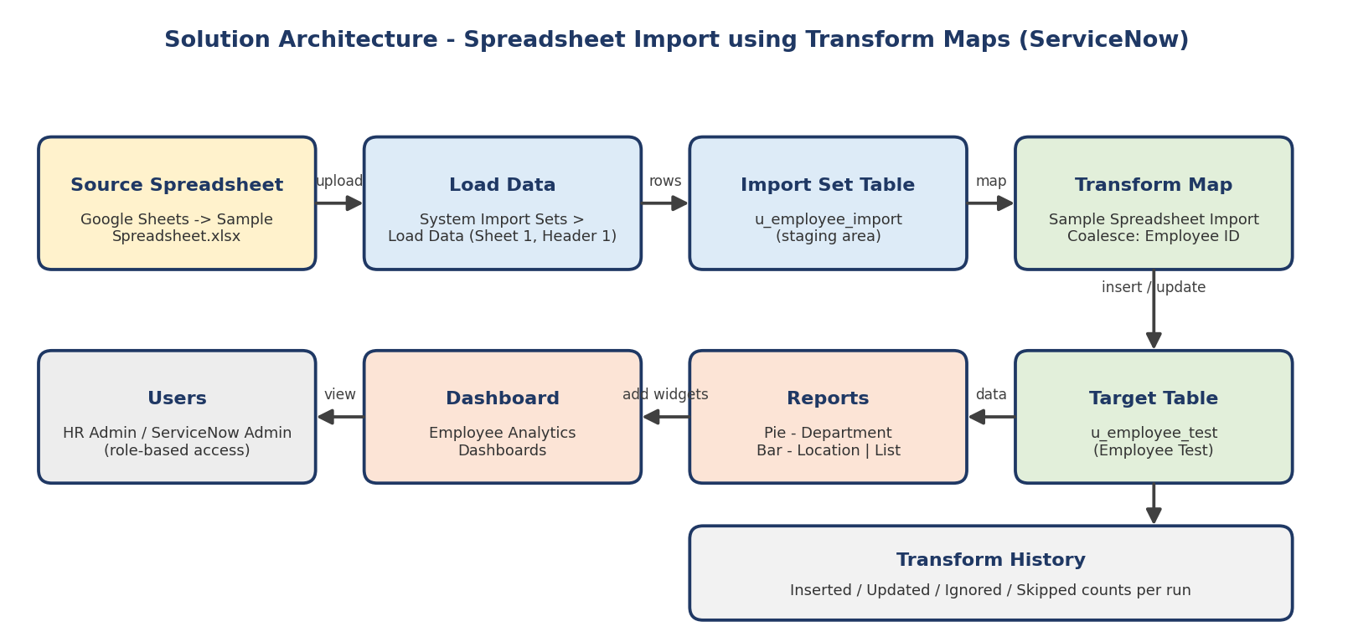

Data Flow:
Step | Component | What happens
1 | Source Spreadsheet | Sample data is created in Google Sheets and downloaded as Sample Spreadsheet.xlsx
2 | Load Data | File is selected as the source, Sheet number 1 and Header row 1; Import Set table Employee Import is created
3 | Import Set Table | Rows are stored in u_employee_import, the staging area
4 | Transform Map | Source fields are mapped to Employee Test fields (Auto Map and Mapping Assist); Employee ID is set as Coalesce
5 | Target Table | Records are inserted or updated in u_employee_test
6 | Transform History | Inserted, updated and ignored counts are checked for every run
7 | Reports and Dashboard | Three reports feed the Employee Analytics Dashboards for HR and admins

Reference: https://c4model.com/

